EXP2:BUS TICKET BOOKING

This experiment focuses on designing a simple Bus Ticket Booking System using the Figma tool. It helps in understanding the basics of UI/UX design and how users interact with different screens in an application. The prototype demonstrates the booking process from searching buses to confirming tickets in a visual and interactive manner.

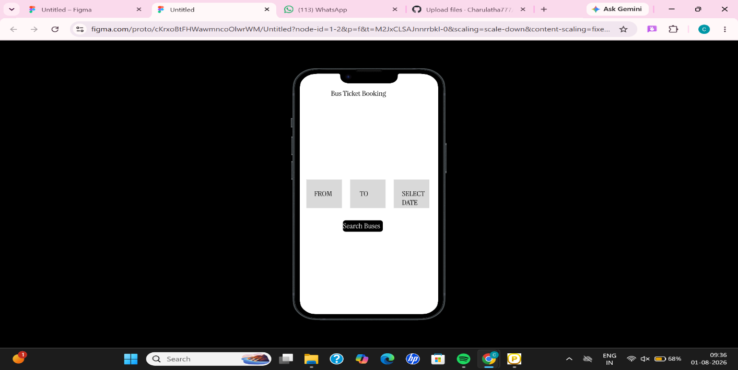
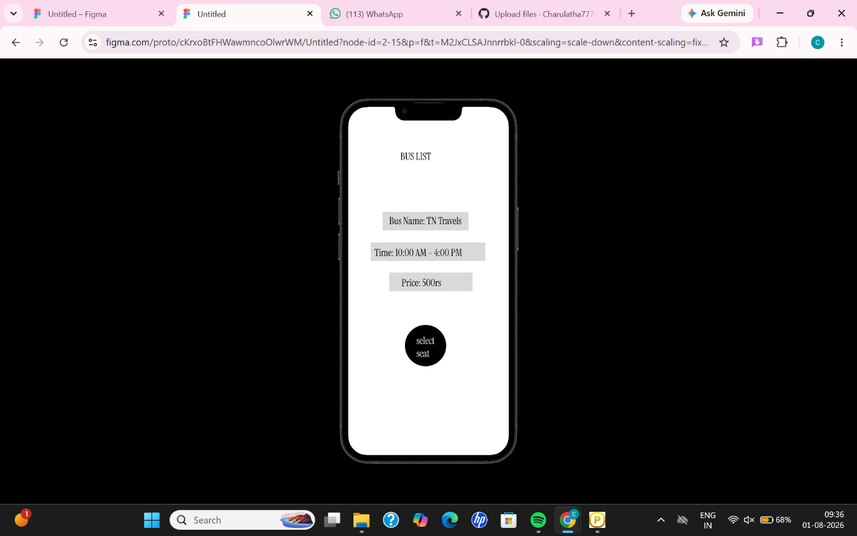
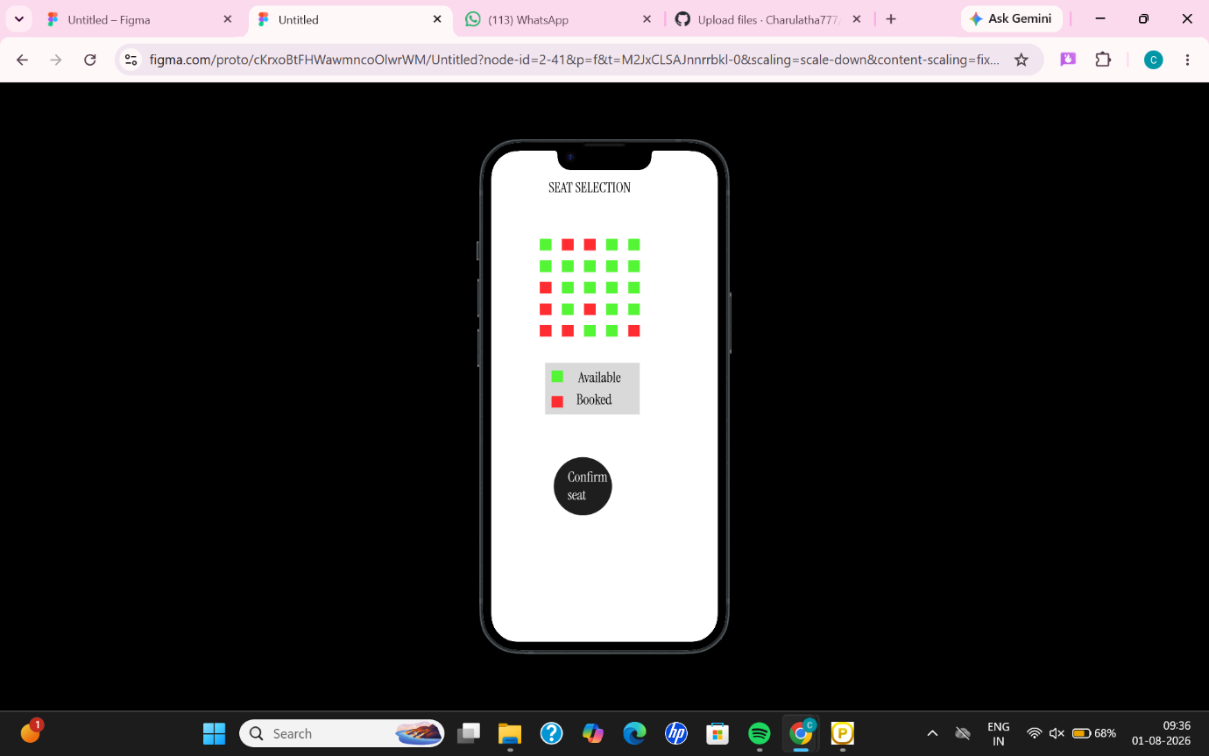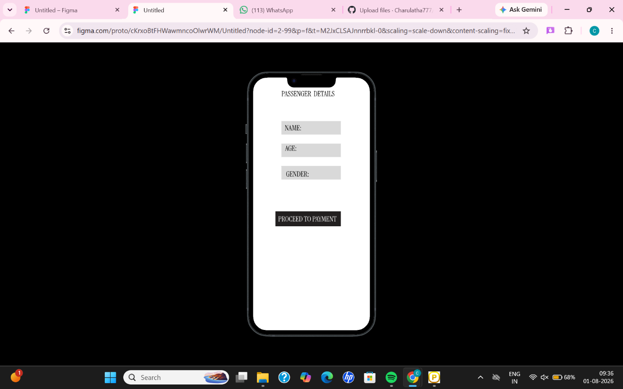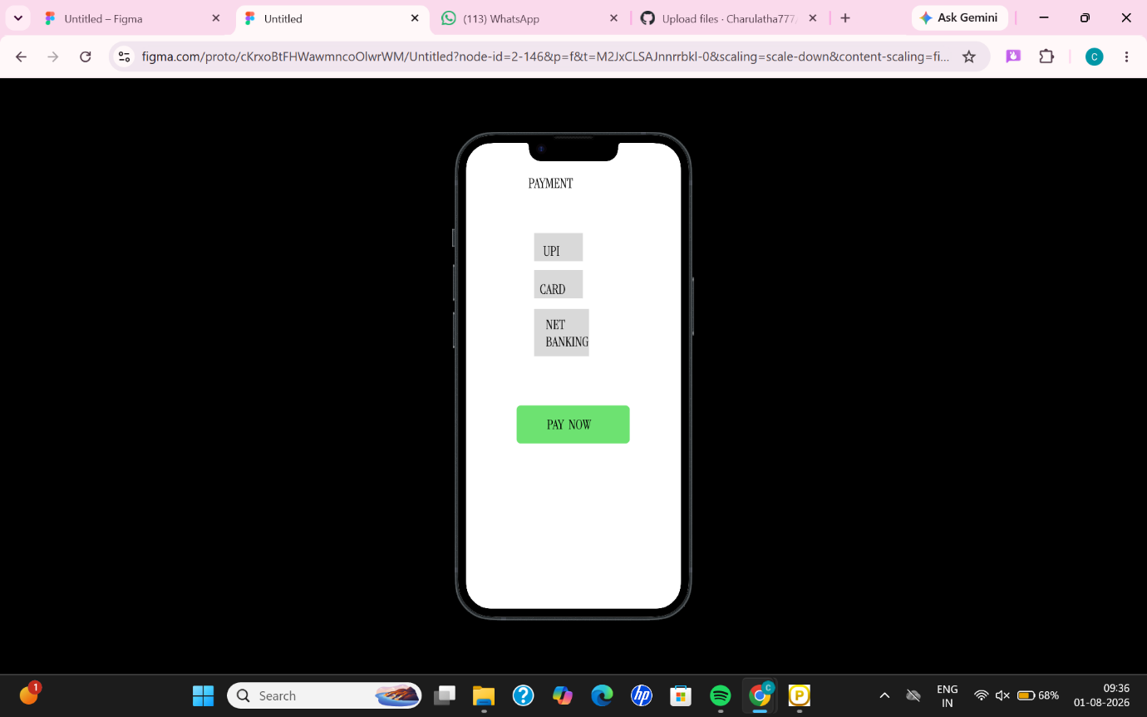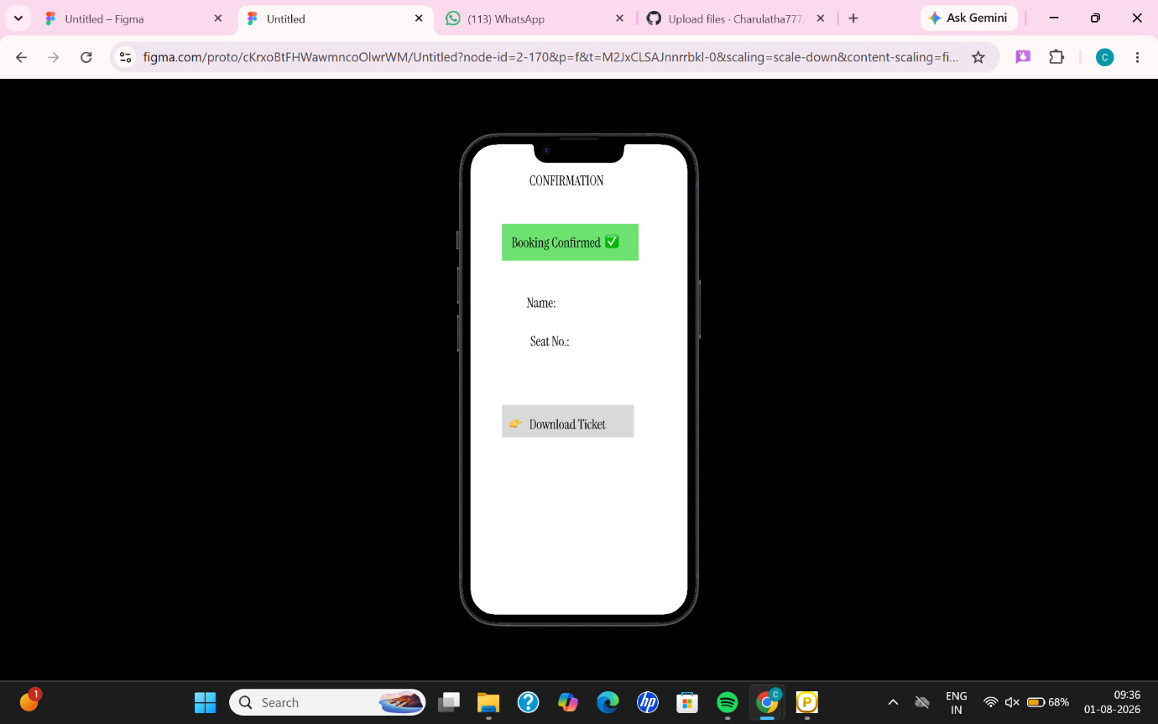

The Bus Ticket Booking prototype was successfully created using Figma. It demonstrates the complete booking flow with simple and clear user interface design. This experiment helped in understanding basic prototyping and user interaction.

